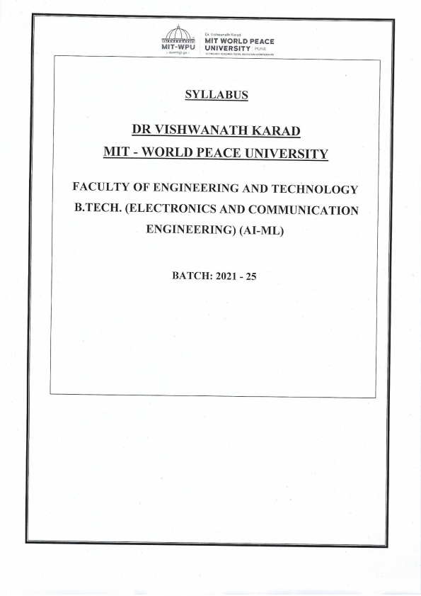
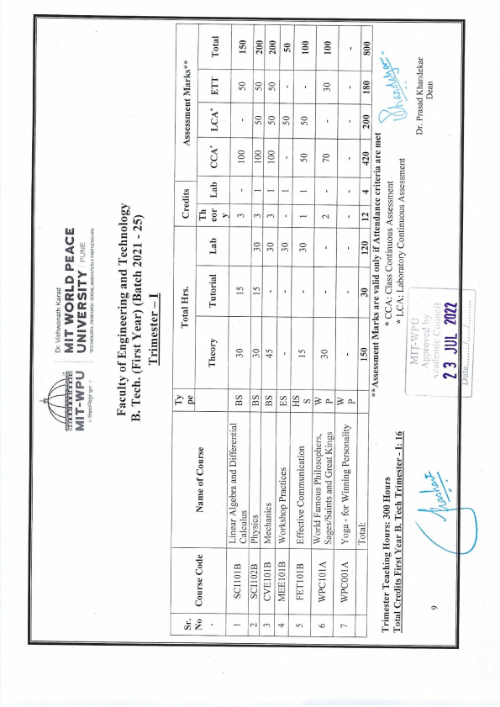
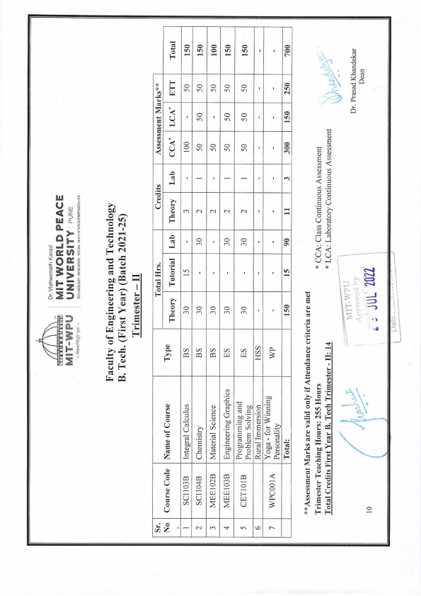
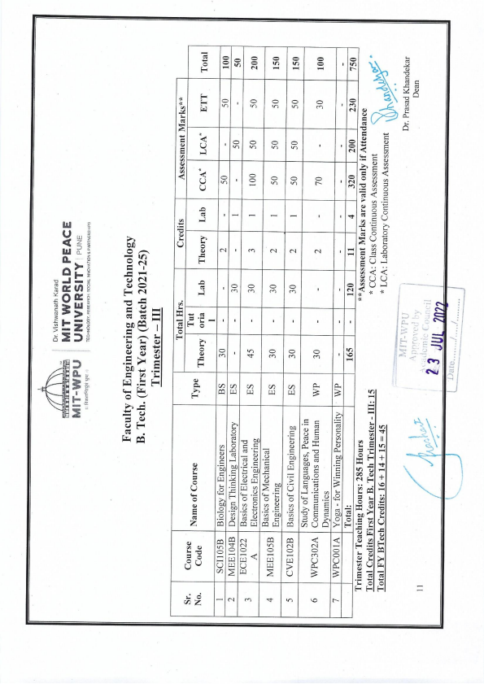
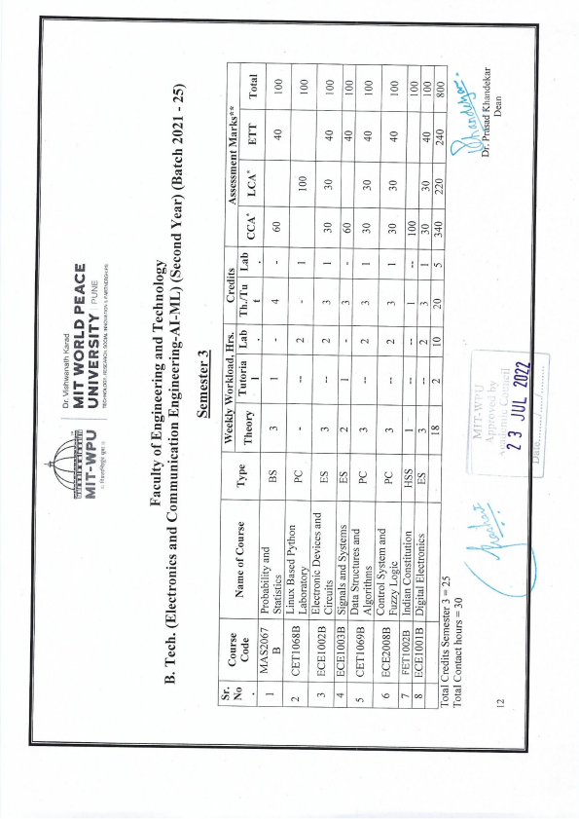
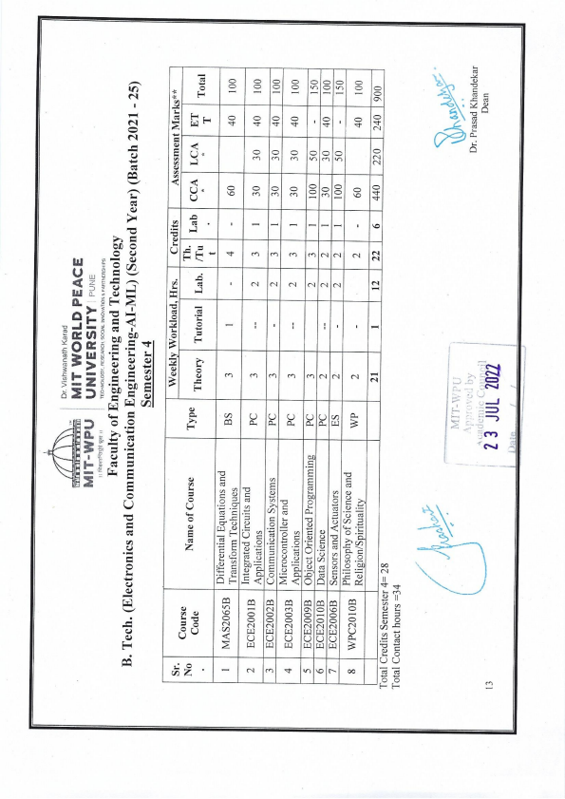
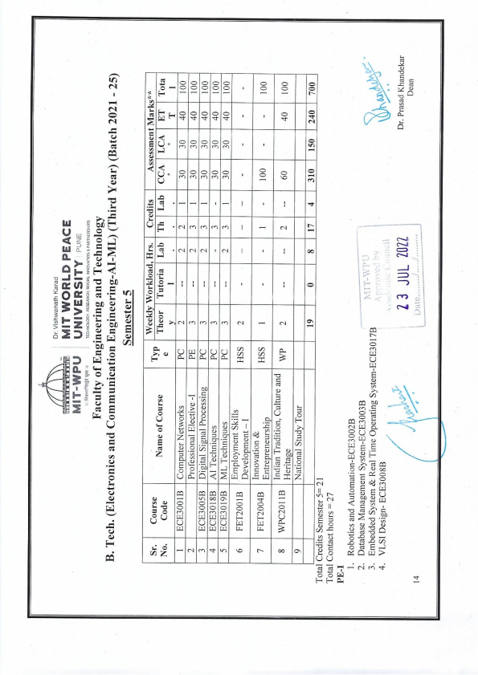
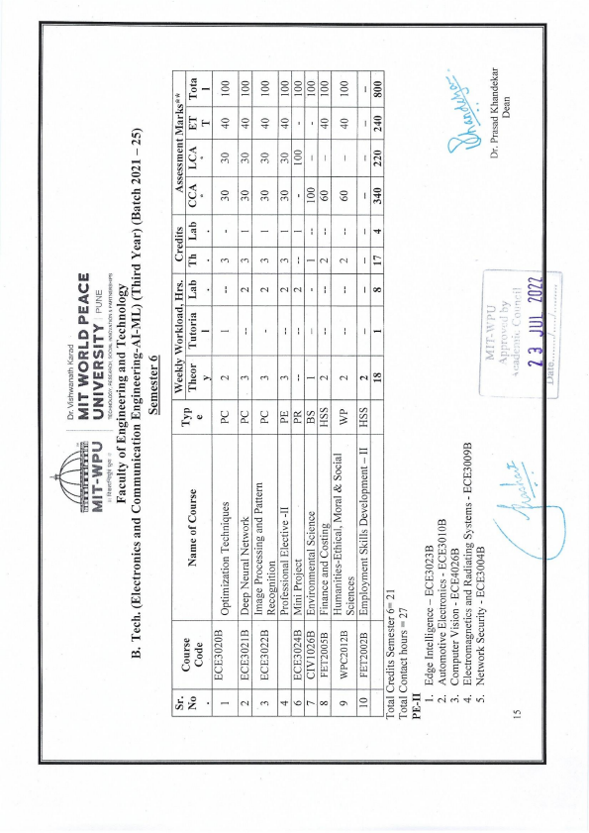
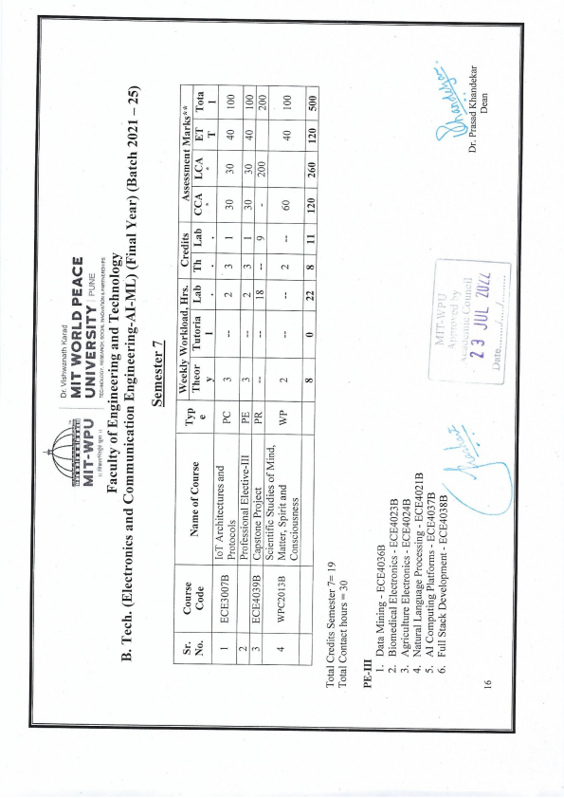
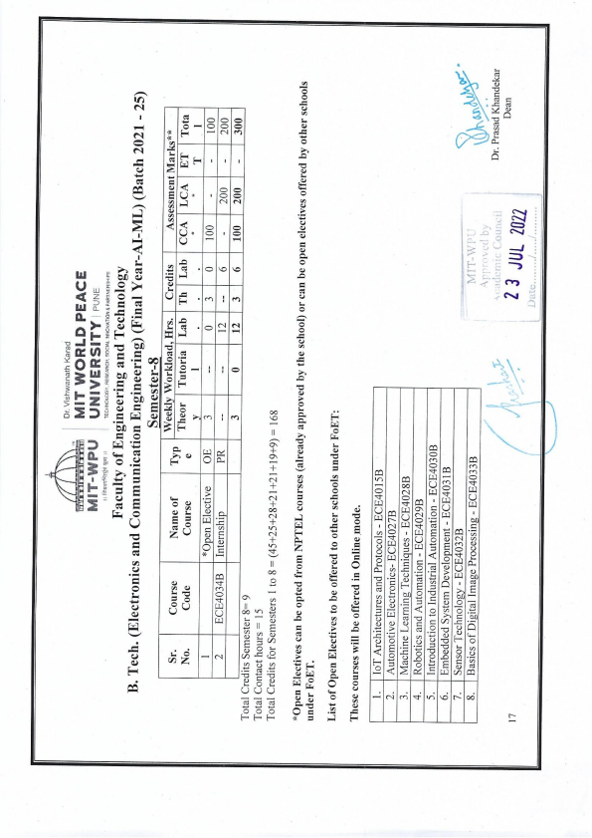

MATHEMATICS COURSE STRUCTURE
Course Code
Course Category | Basic Sciences
Course Title | Probability and Statistics
Teaching Scheme and Credits  Weekly load hrs | L | T | Laboratory | Credits
 | 3 | 1 | -- | 3+1+0=4
Pre-requisites: permutation and combination, set theory.
Course Objectives:
• To understand the concepts of statistical summary measures.
• To learn discrete and continuous probability distributions models.
• To learn about parametric tests used in hypothesis testing.
.
Course Outcomes:
After completion of this course students will be able to
• Use statistical methodology and tools in the engineering problem-solving process.(CL III) • Understand the basic concepts of random variables for analyzing data specific to an experiment (CL IV)
• Use knowledge of basic probability theory in related engineering problems.(CL III) • Analyze the given probabilistic model of the problem.(CL IV)
• Use statistical tests in testing hypothesis on data construct confidence intervals on parameters for a single sample.(CL III)
Course Contents :
Basic Statistics:
Introduction to statistics, Measures of central tendency, measures of dispersion, coefficient of variation, moments, skewness and kurtosis
Random variables:
Introduction of random variables, distribution function for discrete and continuous random variables, cumulative distribution function, joint distribution and joint density function, mathematical expectation and variance.
Correlation and Regression:
Least square approximation-fitting of straight line, second degree parabola and exponential fit, Correlation, rank correlation, Linear regression.


Probability distributions:
Basic probability, conditional probability, independent events, Bayes’ theorem, Standard discrete distributions- Binomial distribution, Poisson distribution, exponential distribution and Geometric distribution. Standard continuous distribution- Normal distribution.
Estimation and Testing of Hypothesis:
Sampling and estimation of parameters, Standard error, Statistical hypothesis, testing a hypothesis, one and two tailed tests of Hypothesis, Type I and Type II errors, level of significance, Chi - Square test, Students t-test, F-test.
Tutorial Exercises:
• Measures of central tendency and dispersion, Coefficient of variation
• Moments , skewness and kurtosis
• correlation
• Least square approximation, regression.
• Conditional probability, Baye’s rule
• Probability distribution functions
• Expectation and variance, joint distribution and joint probability distribution • Binomial, Poisson
• Geometric distribution and Exponential distributions
• Normal distribution
• Chi square test
• Students t test
• F- test
Two tutorials will be conducted using Mathematical Software. Tutorial shall be engaged in four batches (batch size of 15 students) per division.
Learning Resources:
• Ross Sheldon M., “Introduction to Probability and Statistics for Engineers and Scientists”, Fifth Edition, 2014.
• Gupta S. C. and Kapoor V. K., “Fundamentals of Applied Statistics”, Third Edition, S. Chand and Sons, New Delhi, 1987.
• De Groot Morris H. and Schervish Mark J., “Probability and Statistics”, Fourth Edition, Pearson New International Edition, 2010
Web Resources:


Web links:
• https://nptel.ac.in/courses/111/105/111105041/#
• https://nptel.ac.in/courses/111/102/111102098/
MOOCs: NPTEL, MIT OPEN COURSEWARE
Pedagogy:
• Team Teaching
• Tutorials and class tests
• Video technique
Assessment Scheme:
Class Continuous Assessment (CCA): 50 marks
Class test/home assignments | Tutorial | Mid Term Test | Total
10 Marks  (20%) | 25 Marks  (50%) | 15 Marks  (30%) | 50 Marks

Laboratory Continuous Assessment (LCA):NA
Term End Examination : 50 Marks
Syllabus:
Module No. | Contents | Workload in Hrs
 |  | Theory | Tutorial | Assess
1 | Basic Statistics:  Introduction to statistics, Measures of central tendency, measures of dispersion, coefficient of variation, moments, skewness and kurtosis | 8 | 3 | -
2 | Random variables:  Introduction of random variables, distribution function for discrete and continuous random variables, | 8 | 3 | --


 |  | cumulative distribution function, joint distribution and joint density function, mathematical expectation and variance.
 | 3 | Correlation and Regression:  Least square approximation-fitting of straight line, second degree parabola and exponential fit, Correlation, rank correlation, Linear regression. | 10 | 3 | -
 | 4 | Probability distributions:  Basic probability, conditional probability, independent events, Bayes’ theorem, Standard discrete  distributions- Binomial distribution, Poisson distribution, exponential distribution and Geometric distribution. Standard continuous distribution- Normal distribution. | 10 | 3 | -
 | 5 | Estimation and Testing of Hypothesis:  Sampling and estimation of parameters, Standard error, Statistical hypothesis, testing a hypothesis, one and two tailed tests of Hypothesis, Type I and Type II errors, level of significance, Chi - Square test, Students t-test, F-test. | 9 | 3

Prepared By
Checked By
Approved By
Prof. Vaishali M. Joshi Assistant Professor
School of Mathematics & Statistics,
MITWPU, Pune
Prof. Ramaa Sandu
Associate Professor School of Mathematics & Statistics,
MITWPU, Pune
Prof. Dr Prashant Malavadkar
HOS, Mathematics and Statistics, MITPU, Pune.
COURSE STRUCTURE
Course Code
Course Category | Basic Sciences
Course Title | Differential Equations and Transform  Techniques (DETT)
Teaching Scheme and Credits  Weekly load hrs. | L | T | Laboratory | Credits
 | 3 | 1 | -- | 3+1+0=4
Pre-requisites: Linear Algebra and Differential Calculus, Integral Calculus.
Course Objectives:
• To learn linear differential equations and their applications in Engineering. • To learn partial differential equation and their applications.
• To understand Laplace transform techniques and solve differential equations using Laplace transforms.
• To understand Fourier transforms techniques and their applications.
• To learn Z transforms for solving difference equations.
Course Outcomes:
After completion of this course students will be able to
1. identify first order & higher order linear differential equations & solve these equations using various methods. (CL I & III)
2. understand the concept of partial differential equations used in boundary value problems (CL II & III)
3. solve heat equation & wave equation using the method of separation of variables CL III) 4. apply Laplace transform techniques to solve ordinary differential equations. (CL III) 5. apply Fourier transform techniques to solve differential equations involved in real life engineering problems. (CL III).
6. understand Z transforms concept with their properties for solving difference equations (CL II & III)
Course Contents:
Linear Differential Equation:
Review of first order differential equations, Linear Differential Equation of n^{th} order with constant coefficients, Method of variation of parameters, Cauchy’s and Legendre’s Differential Equations, Applications of Linear differential equations-mass spring systems and electrical circuits. (branch specific).

Partial Differential Equations:
Basic concepts, Solution of Partial Differential equations, method of separation of variables for the solution of one- and two-dimensional Heat flow equations, Wave equation.
Laplace Transform:
Definition, Properties, Laplace Transform of standard functions, Laplace transform of some special functions, Inverse Laplace Transform, Applications of Laplace Transform for solving Ordinary differential equations.
Fourier Transform:
Introduction of Fourier series, half range sine & cosine series, Fourier Integral theorem, Fourier Sine and Cosine Transforms, Inverse Fourier Transform. Finite Fourier Transform, Applications of Fourier transforms to problems on one- and two-dimensional heat flow problems.
Z Transform:
Definition, Properties, Z- transform of standard sequences and their inverse, solution of difference equations.
Tutorial Exercises:
1. Linear Differential Equations solution by Shortcut method
2. General, Variation of Parameter methods
3. Applications of Linear Differential Equations.
4. Wave equation,
5. One dimensional Heat flow equations.
6. Two-dimensional Heat flow equations
7. Laplace transform of standard functions
8. Laplace transform of special functions
9. Inverse Laplace Transform
10. Solve ODE using Laplace transform
11. General Fourier transform
12. Fourier Sine and Cosine Transforms.
13. Applications of Fourier transforms to problems on one- and two-dimensional heat flow problems.
14. Problems on Z transforms-standard sequences
15. Inverse Z transform & solution of difference equation.
Note: Introduce Mathematical Software for few tutorial conduction. Tutorial shall be engaged in four batches (batch size of 15 students) per division.
LearningResources:
Reference Books:

1. KreyszigErwin, “Advanced Engineering Mathematics” 10thedition ,Wiley Eastern Limited 2015.
2. Greenberg Michael D.,“Advanced Engineering Mathematics”, 2nd edition, Pearson . 2009.
3. Grewal B.S., “Higher Engineering Mathematics” ,43rd edition Khanna Publishers 2014
Supplementary Reading:
1. O’ Neil Peter, “Advanced Engineering Mathematics”, 8th edition, Cengage Learning 2015.
2. Weber H.J. and Arfken G.B. "Mathematical Methods For Physicists" , 6th edition, Academic Press 2011.
3. Maurice D Weir,Joel Hass, Frank R Giordano, “ Thomas’ Calculus” , 14th edition, Pearson 2009.
Web Resources:
Web links:
• Introduction to second order LDE https://www.youtube.com/watch?v=tGtCajxHoDw • Fourier Transform, Fourier Series, and frequency
spectrumhttps://www.youtube.com/watch?v=r18Gi8lSkfM
MOOCs: NPTEL, MIT OPEN COURSEWARE
• https://ocw.mit.edu/courses/mathematics/18-02sc-multivariable-calculus-fall-2010/ • https://ocw.mit.edu/courses/mathematics/18-03-differential-equations-spring-2010/video lectures/lecture-9-solving-second-order-linear-odes-with-constant-coefficients/
• http://nptel.ac.in/courses/111103021/18
• https://ocw.mit.edu/courses/mathematics/18-02-multivariable-calculus-fall-2007/video lectures/lecture-8-partial-derivatives/
Pedagogy:
• Team Teaching
• Tutorials and class tests/assignments
• Audio- Video technique

Assessment Scheme:
Class Continuous Assessment (CCA): 50 marks
Class
Tutorial Mid
Total
test/home
Term
assignments
Test
10 Marks
25
15
50
(20%)
Marks
Marks
Marks
(50%)
(30%)
Term End Examination: 50 Marks
•

Syllabus:
Module No. | Contents | Workload in Hrs.
 |  | Theory | Tutorial | Assess
1 | Linear Differential Equation:  Linear Differential Equation of n^{th} order with constant coefficients, Method of variation of parameters, Cauchy’s and Legendre’s Differential Equations, Applications of Linear differential equations. | 10 | 03 | --
2 | Partial Differential Equations:  Basic concepts, Solution of Partial Differential equations, method of separation of variables Solution of one and two dimensional Heat flow equations, Wave equation. | 09 | 03 | --
3 | Laplace Transform:  Definition, Properties, Laplace Transform of standard functions, Laplace transform of some special functions, Inverse Laplace Transform, Applications of Laplace Transform for solving Ordinary differential equations. | 10 | 04 | --
4 | Fourier Transform:  Introduction of Fourier series, half range sine & cosine series, Fourier Integral theorem, Fourier Sine and Cosine Transforms, Inverse Fourier Transform. Finite Fourier Transform, Applications of Fourier transforms to problems on one- and two-dimensional heat flow problems. | 09 | 03 | --

5 | Z Transforms:  Definition, Properties, Z- transform of standard sequences and their inverse, solution of difference equations. | 7 | 2

Prepared By
Checked By
Approved By
Prof. Vaishali M. Joshi Assistant Professor
School of Mathematics & Statistics,
MITWPU, Pune
Prof. Ramaa Sandu
Associate Professor School of Mathematics & Statistics,
MITWPU, Pune
Prof. Dr Prashant Malavadkar
HOS, Mathematics and Statistics, MITPU, Pune.
Sign
( < Name >

